New injection moulding machine for large-volume rubber-to-metal bonded parts.

The elastomer injection moulding machine D 968.1000 ZO B900 of DESMA combines ease of operation with versatility and high productivity. From the processing of great material quantities to the easy handling of large-volume rubber-to-metal bonded parts, it can be flexibly applied.

At the same time, using it saves time and money: parallel movements, perfect working conditions due to three-sided accessibility as well as the fact that article demoulding in the clamping unit is being omitted are only a few advantages. They are completed by an optimal utilization of cure time and the possibility of producing different articles in one cycle. A machine concept with high process reliability due to perfectly matched turnkey systems made by DESMA.

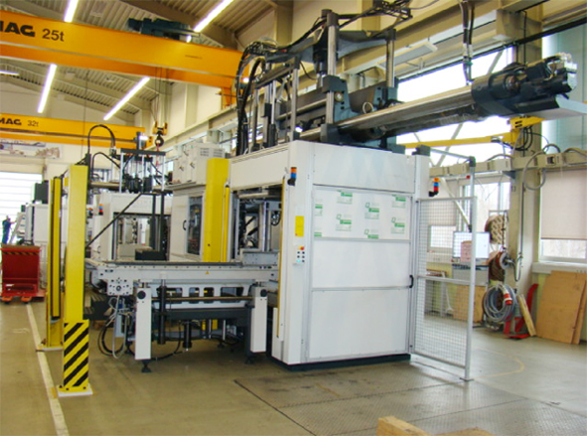
Image 1: Machine 968.1000 ZO B900 with double sliding device and ejecting system

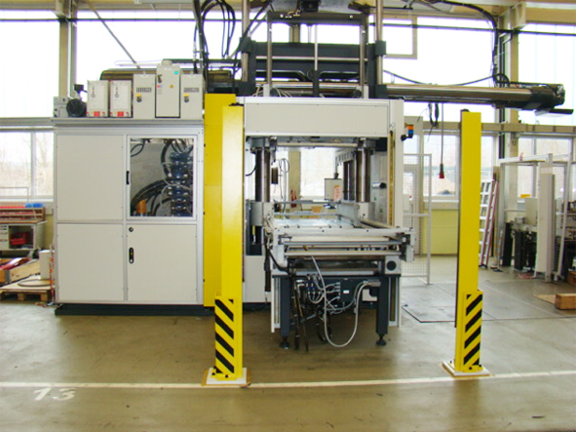
Image 2: Machine 968.1000 ZO B900 with double sliding device and ejecting system

The elastomer injection moulding machine D 968.1000 ZO B900 impressively combines the size and clamping force of a 1,100-ton machine with efficient production. Adding a 22,900 cm³ / 2,050 bar injection unit and using the cold runner technology and flexible sliding systems make an ideal combination. In this case one double sliding device and two identical or different mould bottom parts are used. Even with large-sized articles this results in a clear saving of cycle time. This is being enabled by dislocating all demoulding and feeding procedures as well as the mould cleaning work to the outer station. Concurrent to this, the cure time for new articles is running in the clamping unit.

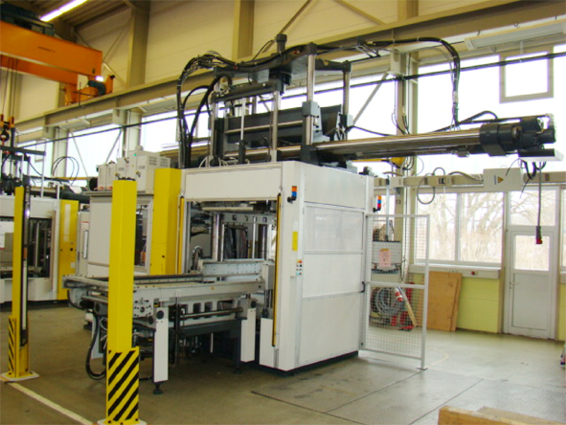
Image 3: Machine 968.1000 ZO B900 with double sliding device and ejecting system

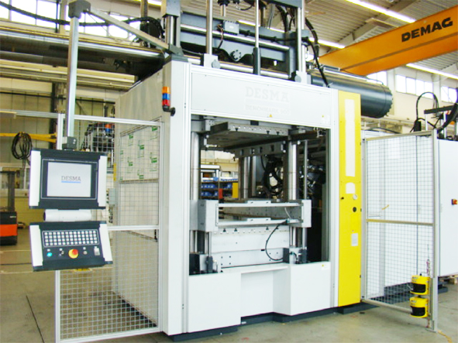
Image 4: Machine 968.1000 ZO B900 with double sliding device and ejecting system

The advantage for the customer: a tremendous saving of time and thus of money. A current example shows that savings as high as 40 % can be achieved in the production of large-volume bearing plates compared to a standard machine. Dislocating cure time partially to the outer station (up to 40 % of total cure time) provides further potential to increase productivity. An additional heating platen integrated into the outer station makes this possible. While the finished parts are removed, the moved out mould bottom part is deposited on this platen by means of vertically displaceable guide bars. An additionally integrated ejecting / demoulding system below the heating platen supports the demoulding of large and heavy rubber-to-metal bonded parts what is advantageous to the operator (cf. pictures 9 and 10). Moreover, the extendible mould bottom plate considerably improves the access to the articles: in the outer station there is free access to it from three sides and therefore allows the unlimited use of lifting tools (e.g. cranes; cf. pictures 1 - 3).

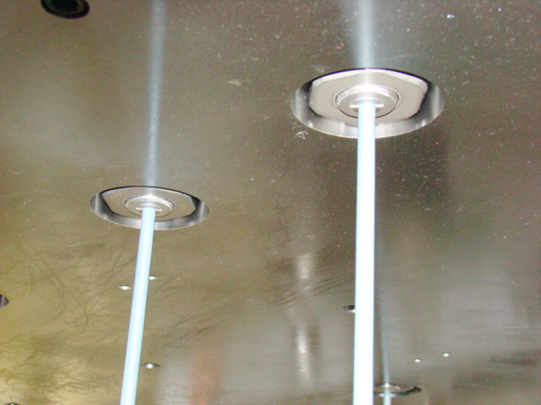
Image 5: Cold runner and mould technology of DESMA know-how and perfection

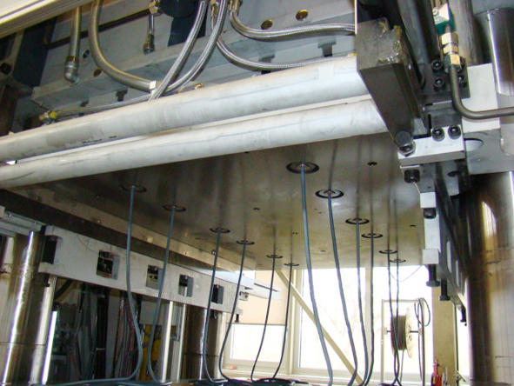
Image 6: Cold runner and mould technology of DESMA know-how and perfection

The usage of a second pump and the connected parallel movements also ensure that all advantages of the DESMA machine are optimally exhausted. If producing large-volume bearing plates, the purchase of a DESMA cold runner system quickly pays off. Especially in case of high-quality and thus very expensive materials, reduction in waste as much as 30 % is not seldom (with an open cold runner system, see the pictures 5 and 6). The usage of a FlowControl system allows for far higher savings yet. Here the customer capitalizes on it in several respects, because the significant cost reduction due to material saving is just one advantage of the cold runners and the matching moulds made by the DESMA mould shop.

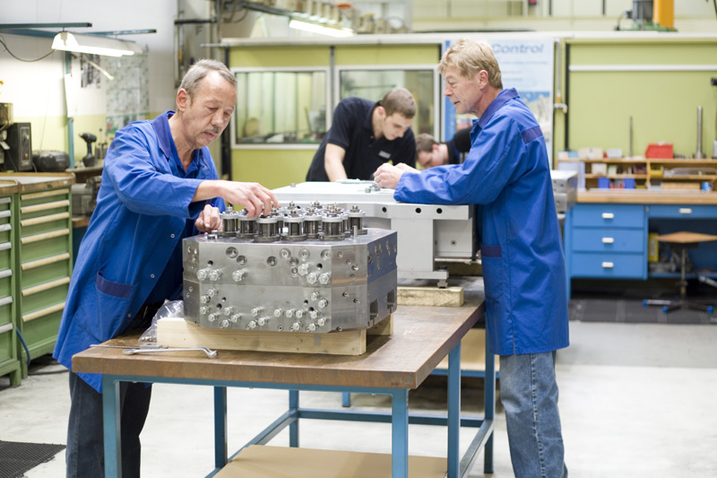
Image 7: Cold runner and mould technology of DESMA know-how and perfection

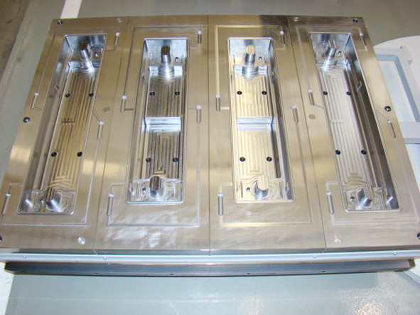
Image 8: Cold runner and mould technology of DESMA know-how and perfection

The high level of flexibility for almost every production process equally argues for this technology. Along with the DESMA FlowControl it is easily possible to even produce different articles of most various shapes and dimensions in one and the same mould within one cycle. The perfected cold runner and mould technology is designed and professionally built by our in-house mould shop (cf. pictures 5 - 8). The benefit for the customer when buying from one source: the individual moulds can be perfectly tuned to machines, sliding devices, demoulding aids (such as the ejector, cf. picture 9) as well as possible cold runner or ITM systems. This is e. g. completed by adapting mould packages to fully automatic turnkey solutions.

Another important aspect of the DESMA cold runner technology lies in its handling: Especially on big machines with long moulds difficult to access, the job of the operator is enormously simplified due to direct injection onto the article. Unnecessary traveling movements are saved, because the distribution deck is not required - the operator does not need to remove any additional runner. The current machine shown in the pictures with special heating platens of 1,400 mm length and of more than 1 m width (cf. picture 11) is a good example of it. The complete material distribution is directly realized in the cold runner system and thus it remains utilizable until the next cycle.

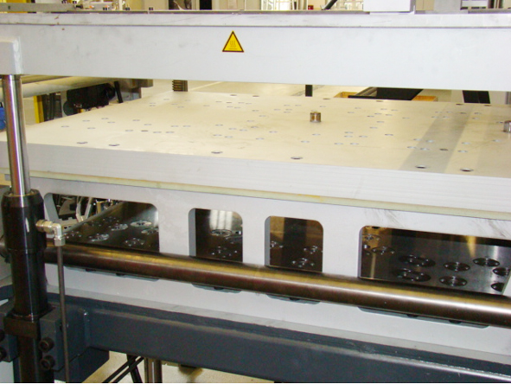
Image 9: Heating platen with subjacent retaining plate for the lift-out bolts

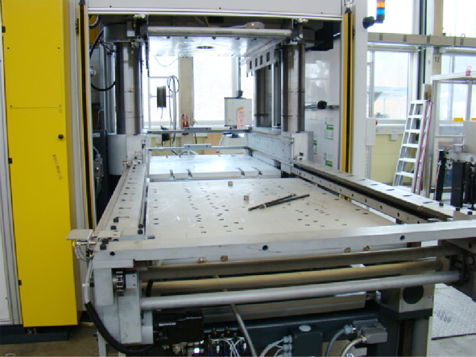
Image 10: Additional heating platen with borings for dipping through with the lift-out bolts

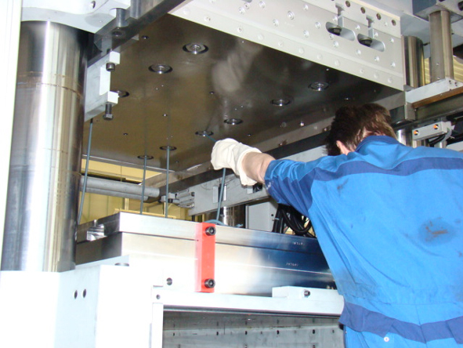
Image 11: Poor accessibility to the clamping unit for the operator, especially in case of big machines with long moulds / cold runners

All advantages summarized at a glance
- High-performance machine to process large material quantities and for easy handling of large-sized rubber-to-metal bonded parts
- Direct cost saving due to the use of a cold runner system
- Unnecessary machine movements are avoided
- No distribution plate with direct injection
- No material loss due to runner
- Production of various articles in one cycle possible
- Easing of working conditions for the staff (no demoulding in the machine's clamping unit)
- Free accessibility from three sides; to the mould in the outer station
- Optimal utilization of cure time
- High increase in productivity
- Economy of time due to parallel movements
- High process reliability due to matched turnkey solutions made by DESMA

