It was a great pleasure for DESMA having won another Product Award of the German Rubber Society (DKG) on the occasion of the last DKT (German Rubber Conference) in Nuremberg in July. The system ZeroWaste ITM already presented at the DESMA Open House 2011 was received with great interest by specialist circles.

The dream of realizing a zero-waste production has become feasible with this technology in the field of precision articles as well. The basic procedure is being based on the well-known ITM (injection-transfer-moulding) process with temperature-controlled pot. This means that the injection chamber (=pot) for material distribution is equipped with liquid temperature control to avoid the compound from being scorched. To this end, various cooling holes and appropriate temperature-control units have been provided. Following the pressing procedure, the injection nozzles are hydraulically shut with needles. These needles are directly shutting on the article and thus do obviate any loss of runner. Apart from this material saving, another advantage is the no longer required removal of runner nipples. This saves cycle time and the risk of scrap rubber carryover due to non-demoulded runners is excluded. Along with the 3-phase ITM-program also available from DESMA, an injection profile similar to the standard injection profile of other injection methods can be achieved.

With this patented development DESMA also wants to bring to its customers' attention not to exclusively focus on the energy issue when purchasing a machine. The share of material in article production still amounts to an average of more than 50 % while the pure share of energy amounts to approx. 2.5 %. Seal productions often show a share of waste of 30-50 %! Hence, the saving potential is incomparably higher.

It goes without saying that all DESMA machines of the latest S3 generation are available with ServoGear hydraulics and EcoSilence temperature-control units as well as with Iso+ heating platens which involve considerable cost-saving potential. By using these new temperature-control units and Iso+ heating platens, it is easily feasible to save 10,000-15,000 kW with a standard-equipped injection moulding machine. This is being completed by the cost-saving potential thanks to Servogear hydraulics. However, here we are talking about possible energy savings of € 3,000-6,000 annually with a 300-ton machine. Material-wise we are very quickly talking about many tens of thousands of euros.

In 2006 DESMA has already been awarded a Product Award from the DKG for its FlowControl cold runner innovation. In the interim, this cold runner system with the injection volume/nozzle to be balanced right at the machine control unit has become a benchmark in the industry and is in use globally.

The DKG Product Award 2012 will conduce to an equally fast market penetration of ZeroWaste ITM. For its customers, DESMA has made this new system available for trials at Fridingen's well-equipped process engineering center.

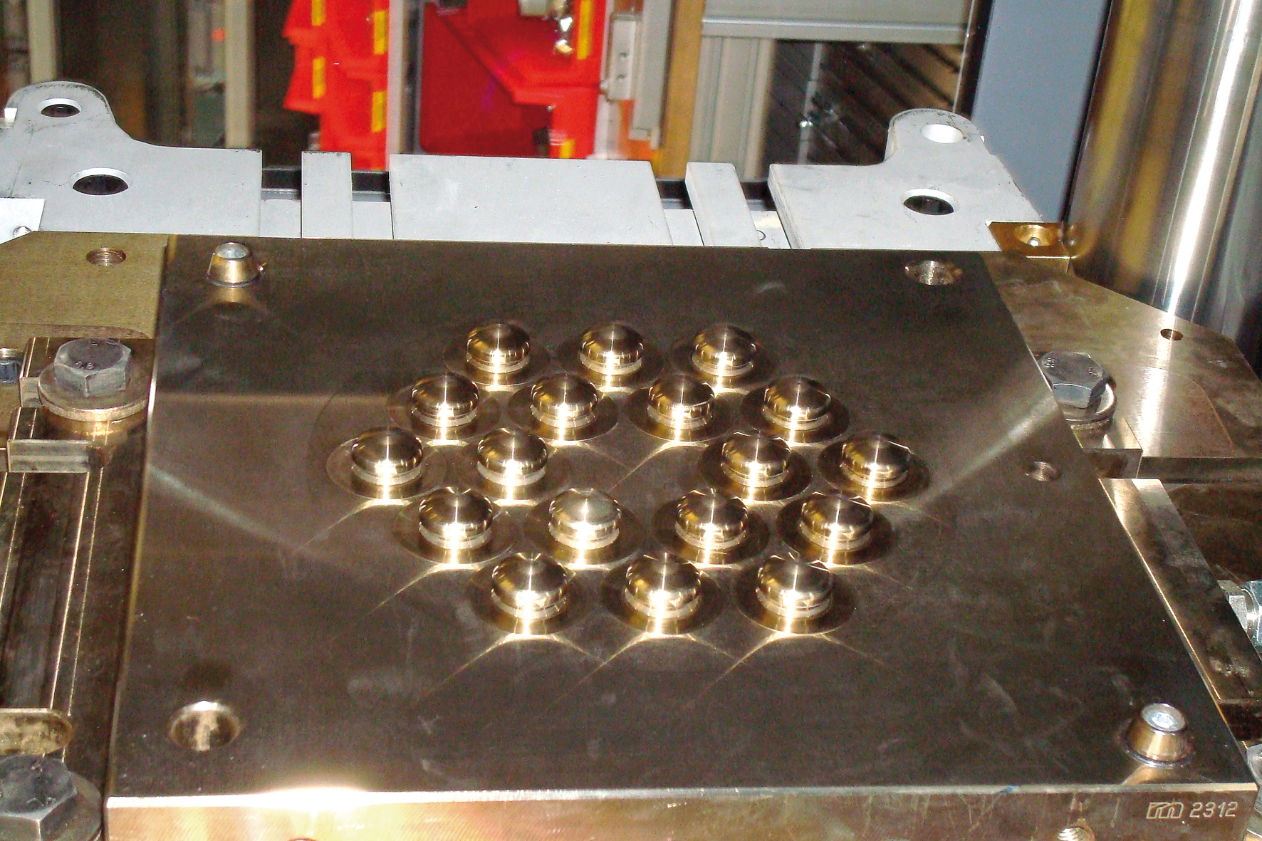
ZeroWaste ITM
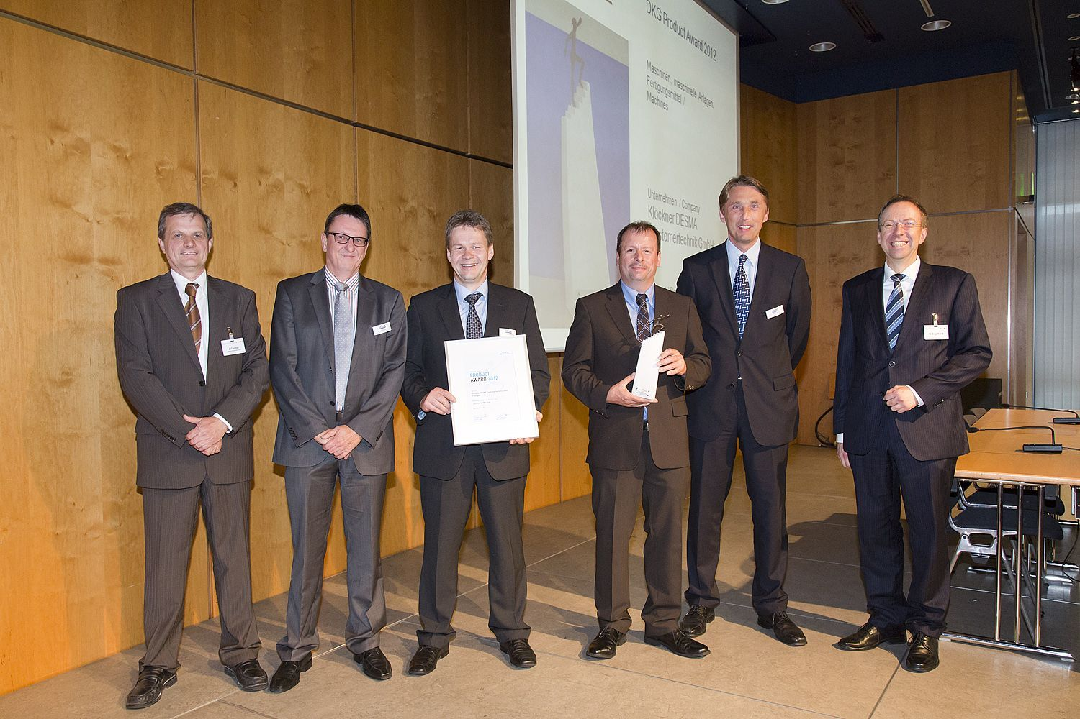
The DESMA Team at the DKG award presentation

