The BENCHMARK series has been DESMA’s most important series since its market introduction at the K 2001. The BENCHMARK clamping system created new standards when it was introduced 9 years ago - and it still represents the best in ergonomics, today. The redesigned S3 version is to follow up on this success.

THE NEW S3 PRESENTS THE UNIFICATION OF NEW EFFICIENCY POTENTIALS

The S3 offers for the first time a hydraulics with servo-drive called ServoGear. This energy-saving hydraulic concept saves around 45 % of the total energy consumption thanks to its 2-pump system. In case of a 4-minute cycle, the consumption of kinetic energy reduced by 45 % means 10-13 % of saving in overall energy consumption. ServoGear also enables exact positioning and impressively low noise levels.
The DESMA patented FIFO-Advanced injection unit has also been redesigned and offers now a bundle of new options. For example large silicone stuffing systems can be integrated even with small injection volumes.

In addition, the injection unit can be fitted with the actively driven feed roller, ActiveFeed, which enables the handling of thicker material strips. The injection unit can even feed in material strips with serious fluctuations in width and thickness, which in turn creates greater flexibility in material procurement, a benefit which really can save money!

The S3 version also features a newly developed non-return system: this hydraulically operated non-return valve is known as PlastControl and patents have been applied for. The result is a much improved level of precision in material dosing and an approx. 50 % higher level of injection accuracy. And what is more, material changing can be effected more quickly and easily.

All new options for injection units are of course available for the new FIFO Advanced and FIFO B Advanced.

The Iso+ heating platens of DESMA reduce the radiating heat by way of a rotating insulation. This reduces energy losses and the heat pollution the operator is exposed to. At the same time a better evenness of temperature distribution is achieved. The saving amounts to approx. 4,500 kWh on a machine with 2,500 kN clamping force.

The new temperature-control units EcoSilence with perfect degree of efficiency of drive and pump allow for an energy consumption per unit to be reduced by 2,000 kWh annually and the noise emission by as much as 6 dB/A.

The BENCHMARK S3 also introduces a newly developed covering generation starring not only larger service-friendly doors but also integrated extraction of material vapours. Taken together with the low noise level, this machine really is a pleasure to operate.

This machine also boasts an integrated hydro-mechanical fast clamping system, QuickLock, which considerably simplifies mould changes. This system is a DESMA in-house development and includes rapid locking of mould center plates.

USER-FRIENDLY MAN-MACHINE INTERFACE

The DRC 2020 HT introduces a new operating panel which raises the benchmark. In addition to optimized user guidance, the focus during development was on simplicity and clarity. The visual interface between man and machine on this unit is complemented for the first time with haptic feedback to the operator at the panel. Available with the new options such as SetupAssist, EnergyControl and FlexInterlock.

EXPERIENCES FROM PRACTICAL USE WITH THE FIRST DELIVERED MACHINES OF THE S3 GENERATION

The first D 968.400 ZO B750 (S3) was delivered to the company Pfisterer Kontaktsystem in Winterbach in week 27/2011. Assembly and commissioning took place without any particular problems. The low noise emission of the hydraulics became immediately apparent. Apart from the sound level reduced, the better closed-loop control of injection represents the crucial advantage. Production manager, Mrs Sachsenmaier: „The closed-loop control of injection works excellently especially in case of slow injection movements. Less efforts have to be taken in process optimization and we achieve higher article quality“. The new visualization is seen as easy to operate and clear. The operating elements with haptic touch and rotary switches are basically good, but an optimization is expedient for the operation of different core pullers.
The new injection unit is praised a lot. The swiveling device, the new guiding system and the piston guide belt are ideally suited for the production of these large articles. In conclusion, Dr. Winter was able to make a clear statement for the future: „We got the feeling having made a good decision. We notice nowhere that we have the first machine of this new series in production. It is clear to us that from now on we are going to purchase machines of the S3 generation only.“

A complex D 968.400 ZO B750 (S3) machine was delivered to the company ZF Friedrichshafen AG in Simmern in week 35/2011. This machine is fitted with much additional peripheral equipment which in addition to the injection moulding machine is moved and controlled. Assembly and commissioning were as expected very demanding which is typically of such machines. The advantages of the S3 generation became quickly evident. Apart from noise reduction, the easy compound change with PlastControl and the simple and quick mould change with QuickLock were considered to be appropriate options. Mr Hähn commented: „QuickLock is basically a good thing, simple to be assembled and easy to operate. The price-performance ratio is very good.“ The new visualization is well done, particularly the quite demanding cycle sequence is considerably clearer and thus easier to understand, so the operators at ZF. The expectations on this new machine have been confirmed in the interim, all new options have proved to be stable and advantageous in everyday production.

We received another positive feedback from the company Nexans in Belgium. The ease of operation of the new visualization is a great step forward according to the responsible employees at Nexans. The distinctly faster reaction times and activation of the movements through rotary key buttons is very handy. Especially the slow movements can be optimally controlled by the new ServoGear hydraulics. „This is an essential hands-on advantage for us“, said Manufacturing Tool & Process Manager. Mr Schulte. The quick and safe mould change by way of QuickLock meets our expectations - it clearly reduces set-up times. The safety for the machine operator is further enhanced as against fastening by means of screws. With critical raw materials we had partially problems before, but with ActiveFeed it is a thing of the past. Quote Mr Schulte: „ActiveFeed is a terrific thing, it really feeds in everything.“

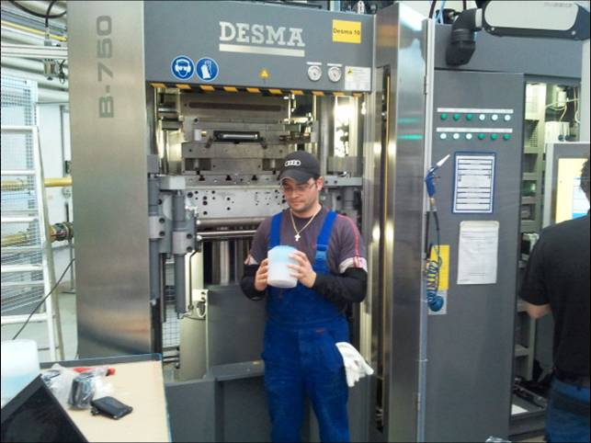
At Pfisterer for silicone processing

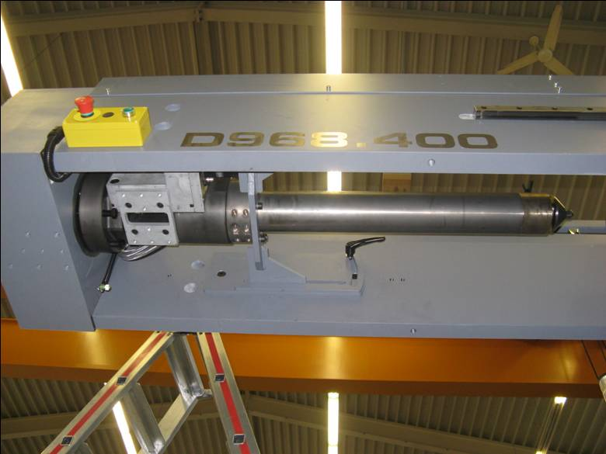
PlastControl

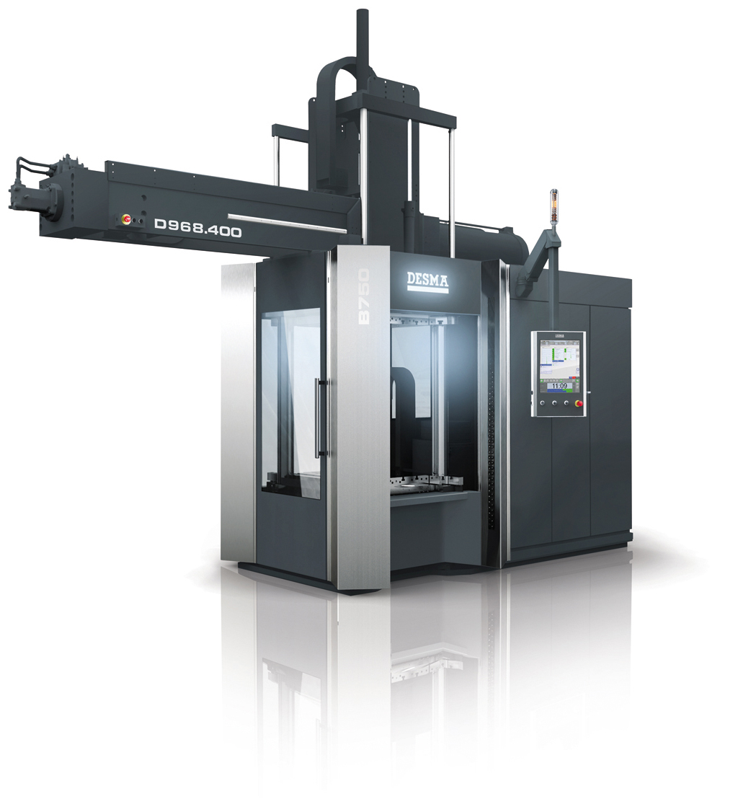
BENCHMARK S3

